Analysis for Death Cases (neural network, Classifier and Regression Analysis)
RNN Results
Realtime Data graph
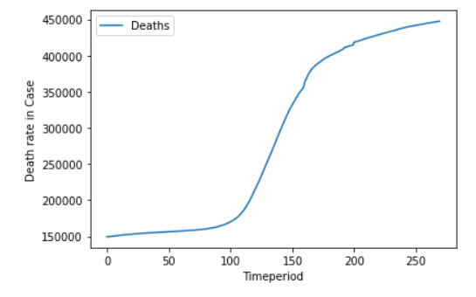

RNN Model Epoches
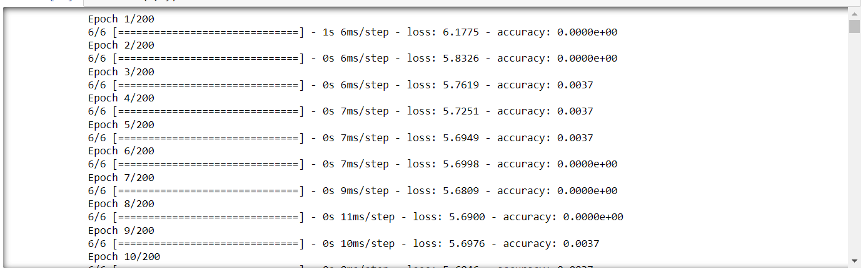
Accuracy Score of testing through RNN
0.64915753558

Classifier Results
Compile Time
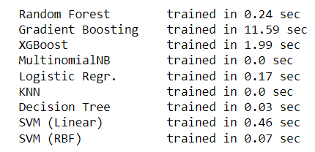
Accuracy Score and Runtime
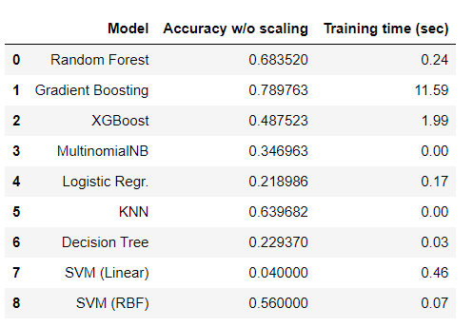

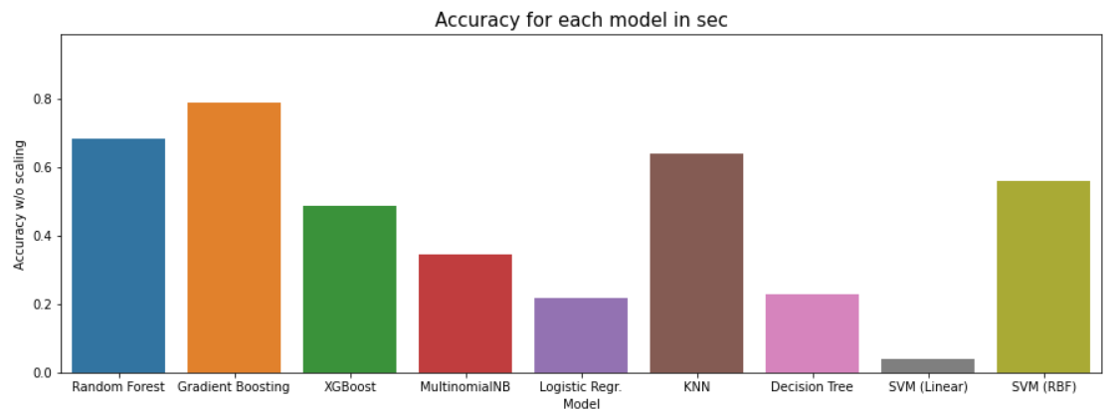
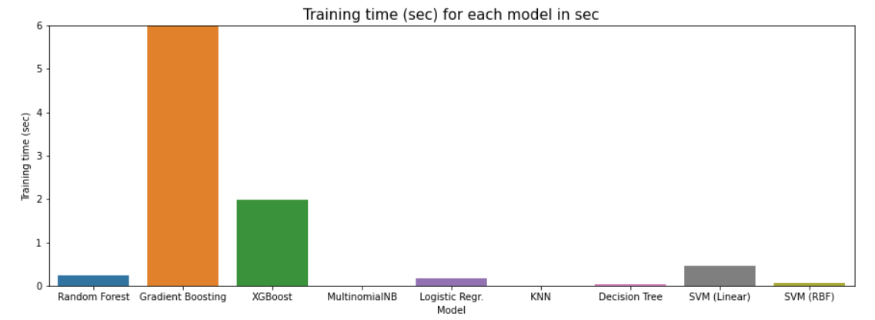

Regression Analysis
Single Linear Regression
Real Time Data analysis in LR
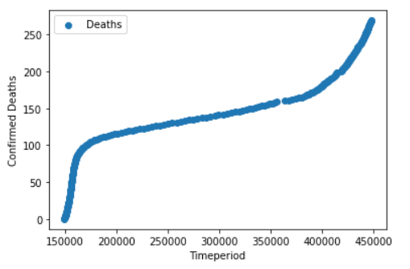
Accuracy Score of Single LR
0.9085916273457588

Multiple Leniar Regression
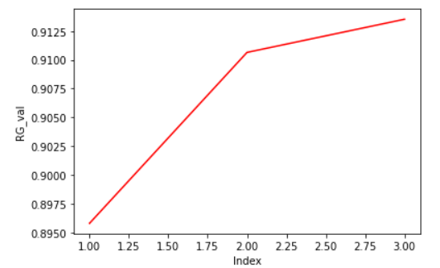
Accuracy of Multiple LR
[0.8957952807770673, 0.910646510502139, 0.9135271447559393]
Avg- 0.9066563120117152
Polynomial Regression
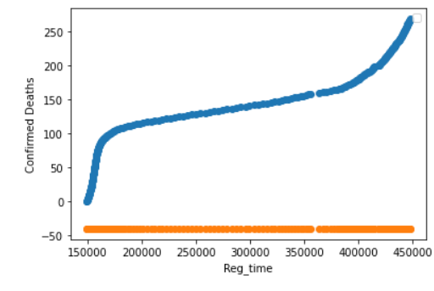
coef_ Score of PR
array([[0.00061115]])

Accuracy Score of PR
-0.3296290
Lasso Regression
intercept_ Score
array([-40.36220307])

coef_ Score
array([0.00061068])

Accuracy Score
0.9061145526776029

Poisson Regression
Accuracy Score
0.14463325260711445

HistGradientBoostingRegressor
Accuracy Score
0.8610311120015043

